HOME PAGE
[ELIMINATE: Where environment meets literature]

AI(R) Poetry
Generator
From air pollution data to poetry across AI, ecology, literature and education
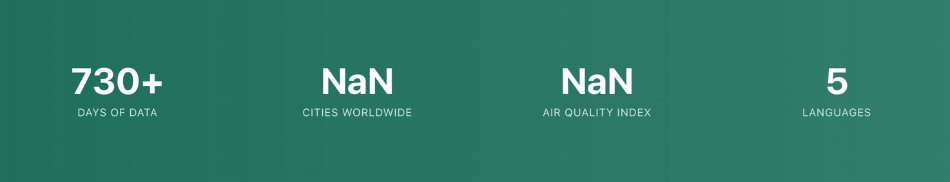

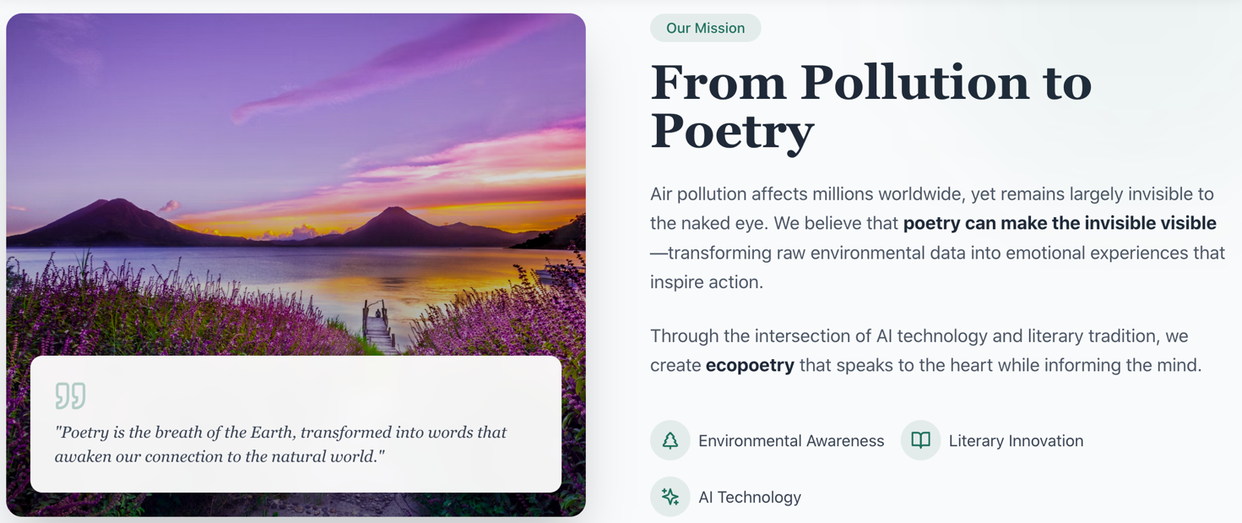

Please add below a section like this, maybe with the picture on the right.
One tool, many possibilities
This software is free, and you are welcome to use it for many different purposes. Let yourself be inspired by the possibilities offered by the AI(R) Poetry Generator: from exploring creative uses of generative AI, to developing educational activities in your classrooms, or simply becoming more aware of air pollution levels in different cities around the world…in an alternative way. We provide you with a special tool: you discover the best way to use it!
Image: https://unsplash.com/it/foto/il-cervello-allinterno-di-una-lampadina-illustra-unidea-zips8ILZd04 free through Unsplash that maybe should be mentioned under the pic).
Add below a section like this, maybe with the picture on the LEFT.

A Creative approach to AI

With this project, AI becomes a tool in support of your critical reflection on climate change, as well as on contemporary writing practices. By transforming air pollution data into poetry, our software fosters awareness of air pollution around the world and of the possibilities for creative expression of it. Through the AI(R) Poetry Generator, AI is much more than software for content creation: it becomes a way to reflect on the relationship between yourself and the world.

Picture: https://unsplash.com/it/foto/persona-che-utilizza-il-computer-portatile-FlPc9_VocJ4 free through Unsplash that maybe should be mentioned under the pic).

[Than all the rest is fine until what comes below]

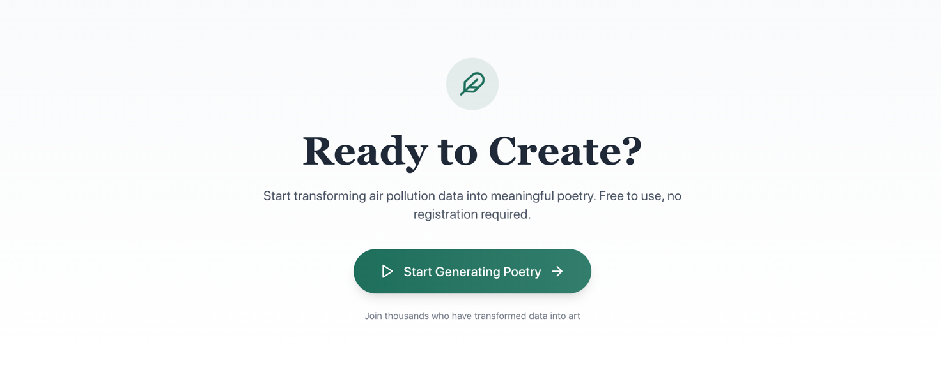

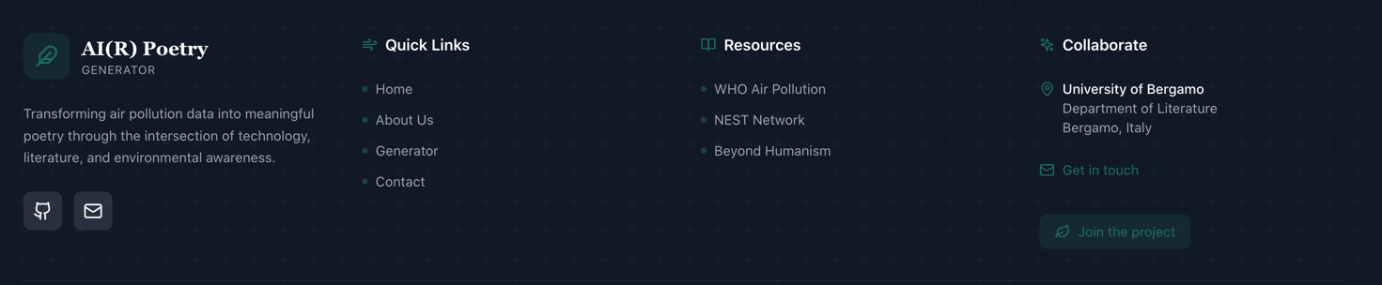

ì
ABOUT
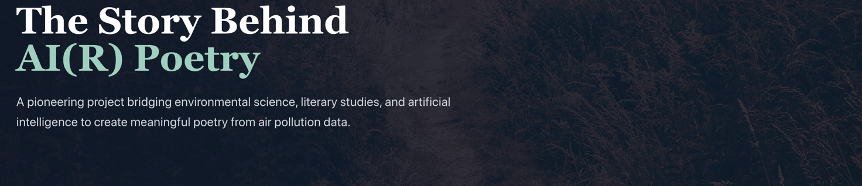

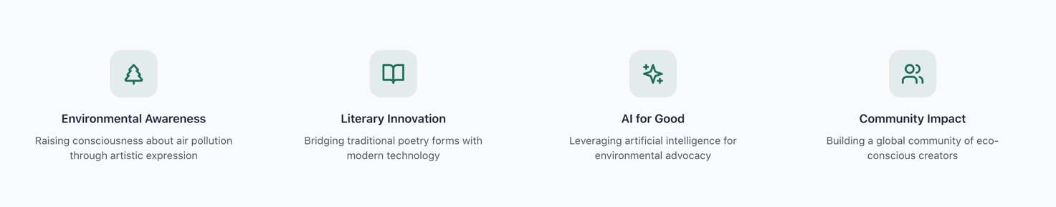

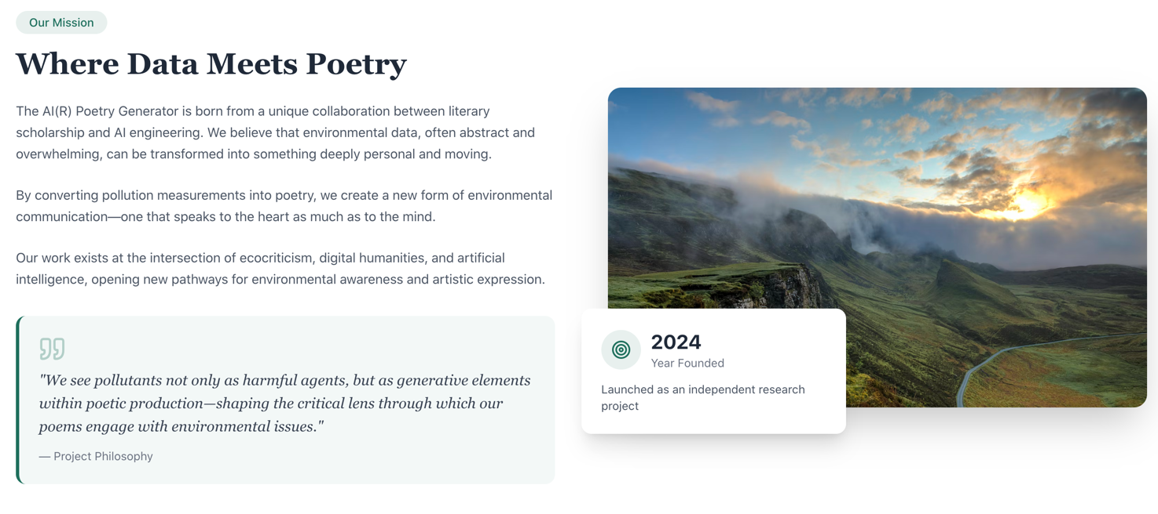

Different Expertise, Shared Visions
Image: https://unsplash.com/it/foto/puzzle-concetto-di-lavoro-di-squadra-macro-shot-QodesUStvjA
The first idea for our AI(R) Poetry Generator was developed in 2024, from an unexpected encounter between a literature scholar and an AI engineer (HERE HYPERLING TO THE WEBSITE PAGE WHICH CONTAINS OUR TWO PROFILES) in Bangalore, India. From that moment, a successful exchange began, through which we imagined an innovative tool enabling artistic, participatory, and creative uses of AI to strengthen environmental awareness on a glocal level.

Despite the scale and visibility of climate change and its many manifestations worldwide, air pollution often remains an “invisible” form. Moreover, affective detachment often persists between our knowledge of environmental emergencies and the way we relate to and act in response to them. A gap is therefore evident between the widespread desire for change and the concrete actions that are actually taken to address the crisis.

How can this challenge be confronted?

We do believe that poetry can respond to our environmental emergency by helping us imagine new horizons, engage emotions in reflecting on current issues, and evoke personal experiences and dreams by activating a deeper involvement with the world, the one we live in, and the one with which we want to live.

At the same time, generative AI–generated poetry opens new visionary possibilities for expressing all this in ever-new forms of (co-)writing texts, making possible unprecedented blends of quantitative and qualitative data for new modes of expression, reflection, and inspiration.

A Journey across Attempts and Trials
Image:
https://www.istockphoto.com/it/foto/albero-vegetale-di-ecologia-e-siccit%C3%A0-ambientale-che-cresce-su-strada-incrinato-gm1096884112-294525804?utm_source=unsplash&utm_medium=affiliate&utm_campaign=adp_photos_sponsored&utm_content=https%3A%2F%2Funsplash.com%2Fit%2Ffoto%2Fpianta-verde-su-muro-di-cemento-grigio-jj10b24qnmU&utm_term=grigio%3A%3A%3A%3Ae667a49a-eb09-4963-be42-50baef21d603
The journey toward the realization of the AI(R) Poetry Generator software followed a real trial-and-error approach, through many stages and attempts: from long reflections to early app prototypes, from effective and less effective tests to exchanges with experts from different parts of the world.
Our project is therefore conceived as a space for reflection in which the world is the protagonist: as a planet we wish to improve, as well as a constellation of people with different experiences, cultures, and backgrounds who contributed to the development of the software.
Through conferences, workshops, and multiple revisions, the project has reached its current version. Please enjoy the AI(R) Poetry Generator, an independent initiative driven by a strong desire to share and improve the planet we inhabit!

A Starting Point, Not an End
Picture: https://unsplash.com/it/foto/un-primo-piano-di-un-tabellone-di-gioco-con-due-coni--nDIecoK1nQ
The poems generated through our software are not intended to be an end in themselves. On the contrary, we hope they will serve as a starting point for developing further activities, debates, and reflections, as well as learning experiences.
Be creative with the contents you create: They are meant to spark curiosity, invite engagement with friends, colleagues, or your learning community. Reuse and reinterpret them in different ways and contexts to raise awareness of air pollution worldwide!
Some examples of what you can do with the poem you develop with our AI are to:
- … support engagement with air quality conditions in your city or in other cities around the world;
- … use it in educational activities with students, comparing AI-generated poetry with poems written by people on similar themes;
- … explore the dynamics of AI-generated composition by changing parameters and letting environmental topics inspire new forms of expression;
- … use it as the basis for parallel projects and programming ideas.
.



As per my profile:
- please update picture from here: https://unibg.unifind.cineca.it/individual?uri=http%3A%2F%2Firises.unibg.it%2Fresource%2Fperson%2F45662
- please eliminate “presenter at the 14th BeyondHumanist Conference” and “Published in inScriptum”

Feel free to edit yours as you deem necessary

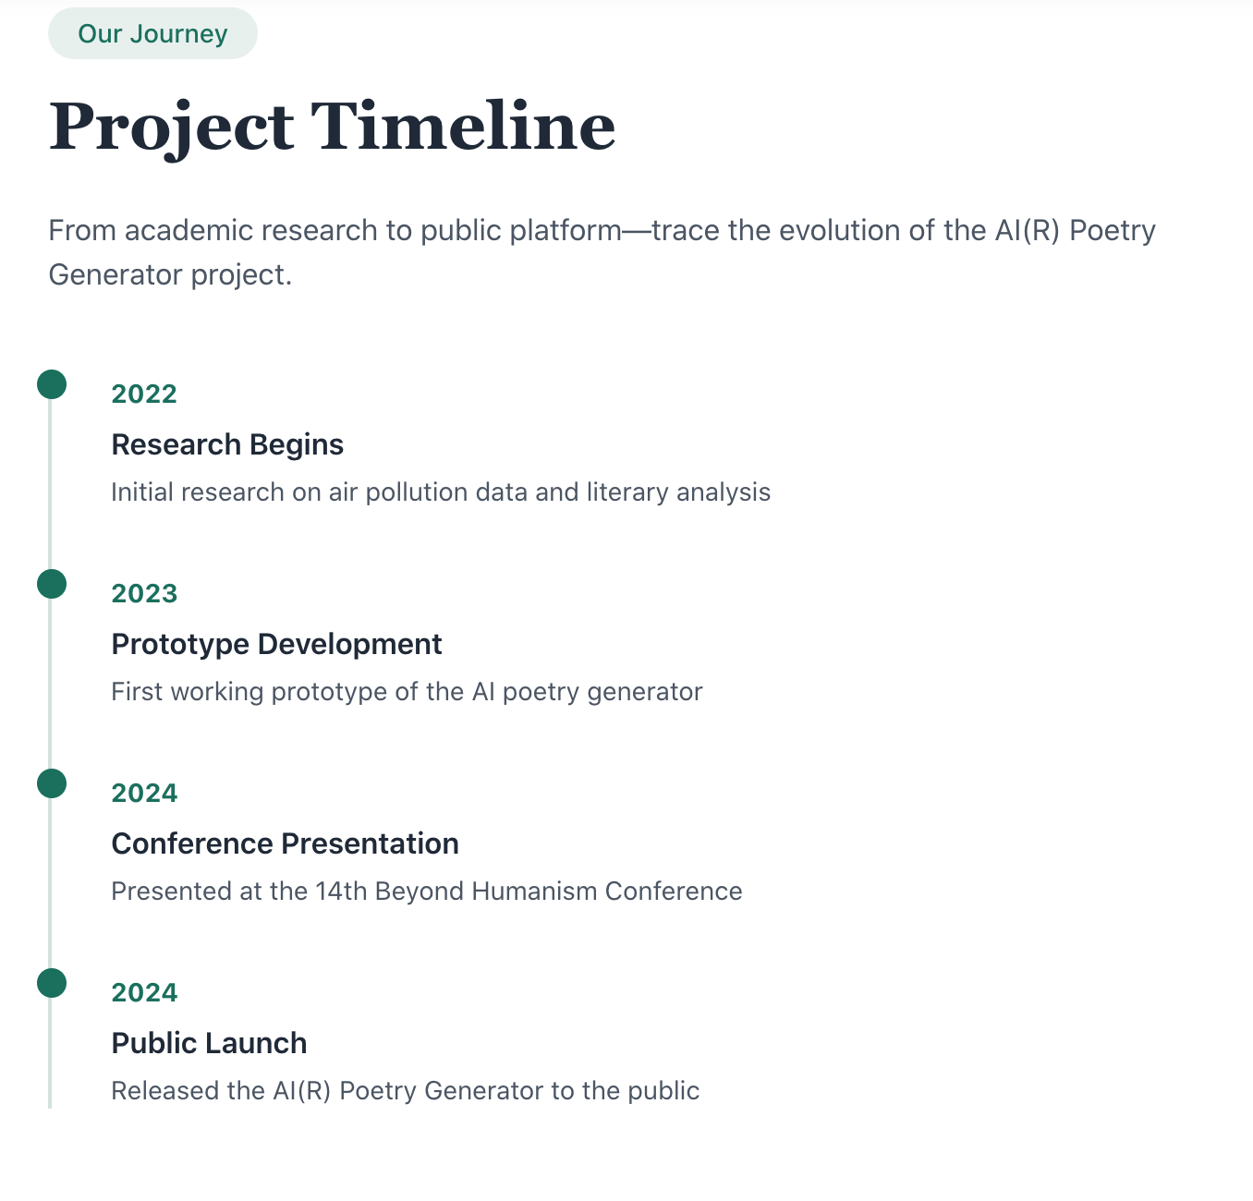

Please, fix as follow:
2022
Research Begins
Initial research on the combination of air pollution data and literary texts.

2023
Prototype Development
Development of the first working prototypes of the AI Poetry Generator.

2024
Conference Presentation
Prototype presented at the 14th Beyond Humanism Conference (2–5 July 2024, University of Lodz, Poland).
Hyperlink: https://beyondhumanism2024.wordpress.com

2025
Workshop Presentation and Trial
New prototype presented at the OCEH – Oslo Center for the Environmental Humanities, University of Oslo, Norway, during the workshop “Pollution-Generated Poetry” (8 October 2025).
Hyperlink: https://www.hf.uio.no/ikos/english/research/projects/oslo-center-for-environmental-humanities/events/oceh-events/other-events/2025/pollution-generated-poetry-a-prototype-across-ai-l.html
Seminar Presentation
New prototype presented at the seminar “AI and Literature” (25–26 November 2025), Østfold University College, Norway.
Hyperlink: https://www.hiof.no/forskning/satsingsomrader/sprak-i-oppleringen/ella/arrangementer/literature-and-ai.html

2026
Public Launch
Release of the free trial version of the AI(R) Poetry Generator to the public.

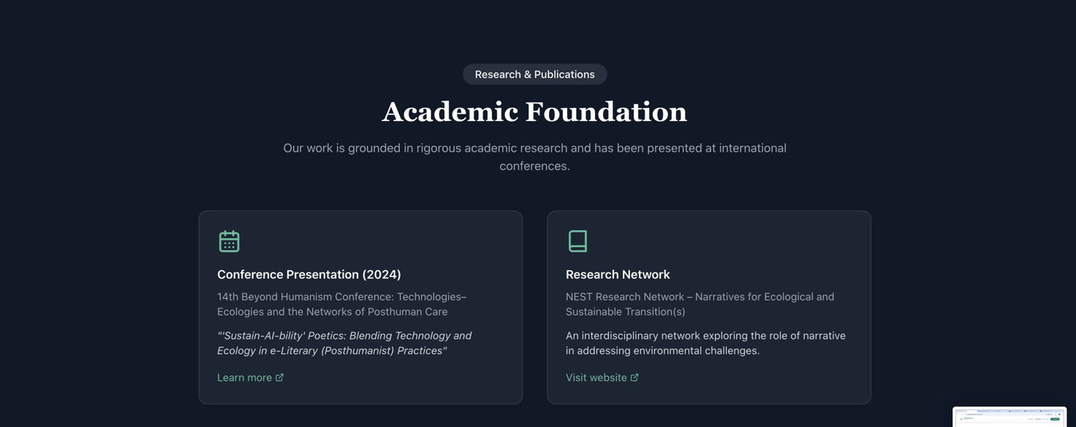
Here add, if possible another box titled
International Workshop

“Pollution-Generated Poetry?” (8 October 2025).

At the OCEH – Oslo Center for the Environmental Humanities, University of Oslo,

Learn more: https://www.hf.uio.no/ikos/english/research/projects/oslo-center-for-environmental-humanities/events/oceh-events/other-events/2025/pollution-generated-poetry-a-prototype-across-ai-l.html

HOW DOES IT WORK?
This should be a new section (page), next to About

First of all an image like this, but more effective should appear

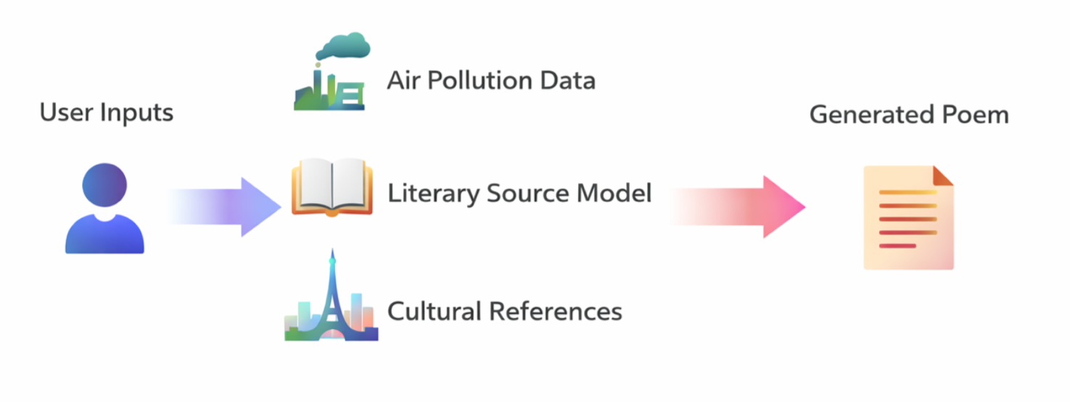

Our software functions through the combination of data that we have integrated into the system, following an algorithm developed through the following steps:

1. Air Pollution Data Collection

We collect both historical data and real-time air pollution data - especially the Air Quality Index (AQI) HYPERLINK: https://aqicn.org/contact/ - from monitoring stations around the world through freely accessible, open-access data platforms that provide environmental information via public APIs. These sources make reliable pollution data openly available for consultation and reuse.
Our software remains in constant dialogue with these data streams. As a result, depending on the selected day, time period, and city, each poem responds directly to the actual pollution levels measured in that specific location at that moment.

2. Literary Sources. Different Forms and Degrees of Criticism
To guide the poetic voice, we have trained the system using carefully selected literary models based on copyright free materials, including texts of different poetic genres.
In addition to these models, we have manually curated a corpus of fiction and non-fiction texts organized by different degrees of criticism toward air pollution. Some texts express subtle concern or reflection. Others adopt a more urgent, radical, or openly critical tone.
If you would like to learn more about this curated corpus, please contact us (LINK TO CONTACT US)
Each degree of criticism is aligned with pollution thresholds defined by internationally recognized standards (based on the Air Quality Index scale as defined by the US-EPA 2016 standard).
• When pollution levels are low, the system draws inspiration from texts with a softer, more contemplative critical tone.
• When pollution reaches hazardous levels, the system shifts toward literary sources with stronger, more confrontational criticism of environmental harm.
HYPERLINK: https://aqicn.org/scale/

3. Web Search for Cultural Models
To ensure that each poem is not only environmentally responsive but also culturally grounded, the software performs a web search using freely accessible sources. This search focuses on cultural references, historical elements, and symbolic or widely recognized features of the selected city.
These references are integrated into the poem so that the text resonates with the specific identity of the place, rather than remaining abstract or generic.

4. Our Algorithm
Once the user’s inputs are defined, the system follows a structured algorithm that combines multiple layers of data and textual parameters, including:
- The air pollution level of the selected city and time period
- The corresponding degree of environmental risk associated with those pollution levels
- A matched level of pollution-related hazard derived from a literary corpus, which models different degrees of critical intensity in the target text
- The chosen poetic form or stylistic framework in which the poem is generated
- Cultural and contextual references associated with the selected city, which are integrated into the text
Through this process, the software dynamically adjusts tone, imagery, and structure, translating environmental data and textual models into a coherent poetic expression.

5. The Result
The outcome is an original poem, uniquely crafted for you. You actively contributed to its creation by setting the parameters.
Each poem is:
- rooted in real environmental data;
- informed by literary and critical traditions;
- connected to the cultural identity of a specific place you have chosen.
In this way, the software does not simply generate poetry—it creates a dialogue between data, culture, critical imagination, and yourself.

